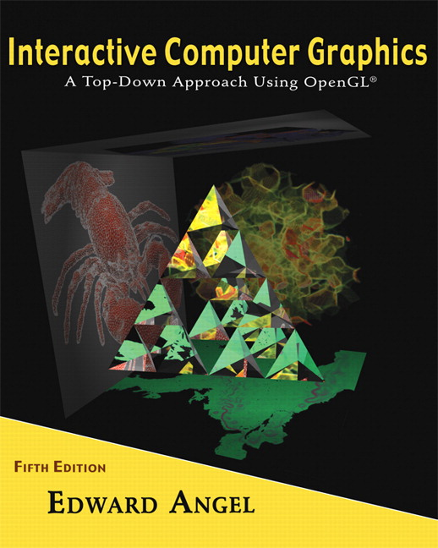

Name: ______________________ Terminal # ____

Programming Assignment 3
(100 points)

The Programming Assignment is to be turned in the first ten minutes of the due date class as:

Hardcopy (with your terminal #!)
Source Code and Screenshots that shows that your Visual Studio 2010 “Programming Assignment 3” PROJECT compiles and runs!

Electronic: Submit the Visual Studio2010 “Programming Assignment 3” zipped PROJECT to BB so you can run it in 200 PGH!

“S’COOL BUS Summer 2012” Color & Shading and Texturing Instructions
(The file “S’COOL BUS Summer 2012.pdf” contains the specifications for the BUS.)

1. The glutCreateWindow OpenGL call will take as parameter “YourLastName BUS Version 3”.
2. Start with the MyBus.c that you have created in Programming Assignment 2 and call the file LastNameBus.c.

3. Lighting and Shading:
Add 1 spot light initially located on the top inside right of (right side looking at the BUS looking from the FRONT) the BUS, distance term a = 1, initial direction towards the center of the BUS. You can use the coefficients from the Lecture 6 and the format from Homework 6 for the MaterialStruct.
You should allow the movement of the light source in 3 positions on each x and z axis, i.e., front left, middle, right and middle side left, middle, and right.
You should allow three changes of the angle of the light, top, middle, and bottom.

4. Texturing:
Texture your BUS by using either a texture similar to the actual BUS or any other BUS siding textures or bump mapping.
If you have several texturing, create a menu to use all of them. I guess this could be the extra credit problem. (20 points)

5. Navigating:
First, the discrete reposition & orientation of the light should be linked to a menu, key, etc.
Second, the LookAt needs to be amended with the following camera positions:

- at the DOOR looking toward the middle back BUS, then back top inside right, and then front top inside right.
- in the middle of the BUS looking at the same as above PLUS back towards the DOOR.
Attach these fixed positions to a menu, key, etc.

Get screenshots of the “YourLastName BUS Version 3” for each view and please comment on what the screenshot is about.

